Marketing Research Paper for Kelston Marketing

Robert Warren
Digital Marketing M.S., Full Sail University
MDL512-O 01: Digital Marketing Fundamentals
Mrs. Ferguson
Feb. 10, 2025

- Organization and Product
Kelston Marketing is a creative marketing studio that immediately sets the tone their website with, “We made it our business to help yours” (Kelston | Marketing and Branding Studio in Southlake, TX, n.d.) combining a vibrant interplay of colors- featuring lucky shamrock, (Lucky Shamrock (Similar) Color | 4a787d, n.d.) and crisp whites- with a clean, warm aesthetic evocative of travel. Kelston`s product is they are a service provider for brand development, creative materials, and marketing needs. Kelston offers a whole suite of services ranging from re-branding, strategy, copywriting, website design, graphic design, organic programming, ideation, and search engine optimization, just to name a few. They do mention their focus is organic media, not paid. (Kelston | Marketing and Branding Studio in Southlake, TX, n.d.)
This may be another opportunity for them to dip their feet into if they decide to venture that route later on. The main social channels this company seems to focus on are LinkedIn, Instagram, and Facebook. Upon reviewing Kelston`s digital presence, an area for improvement is consistency in naming their channels. The official website and email communications go by “Kelston Marketing,” Instagram and Facebook go by “Kelston Creative,” and their LinkedIn goes by “Kelston.” Creating a uniform set of names among their channels will help avoid confusion and reinforce brand identity. This inconsistency is also noted in their target audience in their descriptions, with Facebook and website being for “courageous” companies and then their Instagram being for “creative” companies.
Just setting more uniformity may help to identify the brand. The company follows trends that appear best on their Instagram performance at over 1K followers and seems worst on Facebook with 4. Most of the posts appear to be made on Facebook, yet Instagram attracts the most followers. Shifting that focus may help attract more clients. Trying to do some cross-promotion through Instagram to Facebook would be a great opportunity if they are looking to grow Facebook as well. This could be a good experimentation to do stories through Instagram that link to Facebook. What Kelston has done really well with their marketing efforts across all their channels is a consistency of brand color and their recognizable Kelston logo (which does work its way into the IG even though it is used for the highlights.) The aesthetic they bring is very pleasing to the eye and creates a sense of adventure with some whites, light browns, greens, and light blues. The fonts are also very clean and sleek.
Most of the posts are very eye-pleasing as well and create a sense of travel with photos by the beach and then luxurious hotels. The website is good at connecting an audience through ethos by saying, “Good Design by Good People.” (Kelston | Marketing and Branding Studio in Southlake, TX, n.d.) That is a very strong quote and did a really good job at defining ethos to the audience checking out the website.
- Company History
Stephanie Cross, a graduate of the University of Arizona, founded Kelston with 15+ years of marketing experience. (Stephanie Cross, n.d) Coming into her brand, she brought the experience of working for luxury brands like Michael Kors, St. Regis hotels, and more. (Kelston | Marketing and Branding Studio in Southlake, TX, n.d.) Much of her experience comes from the 8+ years at Starwood Hotels & Resorts Worldwide, Inc., where she got promoted three times from Field Marketing Manager to eventually Senior B2C Marketing Manager in the Americas. (Stephanie Cross, n.d) Now, she operates as the Head of Brand Marketing for her company, Kelston. Through the company, she aims to tell a story that resonates in every project. (Kelston | Marketing and Branding Studio in Southlake, TX, n.d.) What is inspiring is to see the array of company industries in which Kelston Marketing provides marketing materials. These can include such industries as interior design + architecture, hospitality, food + beverage, and consumer brands. Kelston Marketing is a business created from the success of a woman who took her marketing experience and used it to open her own marketing agency.
- Current or proposed Mission Statement
The mission statement for Kelston is “We made it our business to help yours. Branding agency for businesses that want to feel liberated” (Kelston | Marketing and Branding Studio in Southlake, TX, n.d.) Analyzing the mission statement, the company does a very good job of defining who it is as a branding agency. Why they do it is to “make businesses feel liberated.” (Kelston | Marketing and Branding Studio in Southlake, TX, n.d.) The biggest thing they can improve on is more clearly defining how they make the businesses feel liberated. This can be best described as through creative, organic media. These are the three fundamental questions; “What does your business do? How...? And why” (Kramer, 2024)
Another way to look at this is defining a core audience, what will be delivered, and the outcome or benefit. (How to Write an Inspiring Content Marketing Mission Statement [Examples], 2022) While the point is made that the branding agency will help businesses, it is just missing the services that will be delivered. The benefit will be the business will feel liberated. Overall, the mission statement for Kelston is very strong, well defined in two sentences, and just needs to explain more in the mission statement what they can do for businesses.
- Target Market
The target market for Kelston marketing is very well defined on their website. Kelston labels their target market as “interior designers, hotels, and restaurants” (About Kelston Marketing | Dallas Marketing and Branding Studio — Kelston | Marketing and Branding Studio in Southlake, TX, n.d.-b) They do a very good job of reflecting this through their social media. Kelston shows images of interiors, food, drinks, quotes, and more. Most of Kelston's posts reflect an audience that the companies, hotels, restaurants, and interior designers may have a mid 20`s- early 30`s demographic.
The use of mid-20s models, coffee, laptops, alcoholic drinks, empowering quotes, and books may tend to the mind 20`s- early 30`s audience. The style of the posts just mentioned may also tend to the entrepreneurial spirits and younger-run businesses. The most successful of Kelston`s social media is Instagram the highlights are well organized, and the posts are well-filled, but there is an opportunity for more reels and carousels.
- Industry and Environmental Analysis using P.E.S.T.E.L. model
A. General State of the Industry
The general state of the marketing consulting industry for 2025, according to Barnes Reports, is up in a four-year comparison (not including the predicted year) and is also predicted to go up in 2026. (Barnes Reports, p.13) The report shows a pretty promising outlook for the marketing consulting industry as in these four years from 2022-2025 (not including the predicted year), every year, the marketing consulting industry has gone up in establishments, sales, and employees. It is expected to go up in 2026 as well. The U.S. is shown to have the largest amount of establishments, sales, and employees. The only challenge to keep in mind with this is the more people in the industry, the more competition. However, as long as more businesses keep popping up needing more marketing services, the competition may not be so harsh with marketing consulting establishments going up.
Some of the biggest areas for marketing consulting service employees, the top 10 areas with the most employees, in the United States as of 2025, as pulled from the Barnes Reports, pages 84–112 in order of amount of employees, are by place (employees); 1.New York-Newark-Jersey City, NY-NJ (44,936) 2. Los Angeles-Long Beach-Anaheim, CA (36,213) 3. Detroit-Warren-Dearborn, MI (25,533) 4. Chicago-Naperville-Elgin, IL-IN (19,982) 5. Miami-Fort Lauderdale-West Palm Beach, FL (19,368) 6. Boston-Cambridge-Newton, MA-NH (14,856) 7. Atlanta-Sandy Springs-Roswell, GA (12,151) 8. San Francisco-Oakland-Fremont, CA (11,597) 9. Dallas-Fort Worth-Arlington, TX (11,234) 10. Washington-Arlington-Alexandria, DC-VA-MD-WV (10,100)
B. P.E.S.T.E.L. Analysis and ChatGPT Response Inclinations
a. Political:
When prompted with “Give me three examples of PESTEL, Political, and how it is making an impact in the marketing consulting industry..” the ChatGPT-generated text mentioned the points “Government Advertising Regulations, Data Privacy Laws, and Government Policies on Sustainability and Green Marketing.” (OpenAI, 2025) Data privacy acts are something that has taken off this year- with potentially more to take effect. An example of this is the data privacy concerns with TikTok that may cause a full o- ban in the U.S. (Phelan, 2025) However, there are still many alternatives, such as Instagram Reels, YouTube Shorts, and Snapchat Spotlight. Another thing to keep an eye on is the American Privacy Rights Act, which established strong data security systems. (Larrison, 2025) The key is to make sure that when looking at politics, threatening falls within the frame of timeliness of whatever is going on at the current time.
b. Economic:
When prompted with “Give me three examples of PESTEL, Economic, and how it is making an impact in the marketing consulting industry..” the ChatGPT-generated text mentioned the points; “Economic Downturns and Budget Cuts, Growth in Digital Advertising Spending, and Inflation and Rising Operational Costs.” (OpenAI, 2025) The biggest concern for marketers is being asked to do more with less cash.(Bowler, 2025) As inflation may remain a concern building a strong brand should be essential, maximizing customer retention, looking for new market opportunities (within the U.S. as with more potential outside U.S. tariffs being put in place,) creating the best customer communication and making the most out of all the social media channels. (Collective Alternative, n.d.)
c. Social:
When prompted with “Give me three examples of PESTEL, Social, and how it is making an impact in the marketing consulting industry..” the ChatGPT-generated text mentioned the points; “Shifts in Consumer Behavior Toward Digital Engagement, Increased Demand for Diversity & Inclusion in Branding, and Growing Consumer Interest in Sustainability & Ethical Marketing.” (OpenAI, 2025) This is important to note younger audiences are shifting their focus to short form video. (Dodds, 2024) According to Wordstream, “Some 59% of consumers polled said they are more loyal to brands that stand for diversity and inclusion in online advertising, and 59% also said they prefer to buy from brands that stand for diversity and inclusion in online advertising.” (McCormick & McCormick, 2025)
d. Technological:
When prompted with “Give me three examples of PESTEL, Technological, and how it is making an impact in the marketing consulting industry..” the ChatGPT-generated text mentioned the points; “Artificial Intelligence (AI) and Automation in Marketing, Rise of Data Analytics and Predictive Marketing, and Emergence of Augmented Reality (AR) and Virtual Reality (VR) in Marketing” The rise of Ai has happened very quickly from Hey Siri, Alexa, Google, Cortona, ChatGPT, then DeepSeek Ai. There has been lots of evolutions from Tesla`s self driving cars, Elon Musk`s robot, and more. With the rise of Ai it is only very important we learn as much as we can on it. This can be as simple as an automated Voicemail to the more complicated such as Chatbots.
e. Environmental:
When prompted with “Give me three examples of PESTEL, Environmental, and how it is making an impact in the marketing consulting industry..” the ChatGPT-generated text mentioned the points; “Demand for Sustainable and Eco-Friendly Marketing, Regulations on Carbon Footprints and Digital Advertising Energy Use, and Natural Disasters and Climate Change Affecting Market Strategies.” (OpenAI, 2025) These are important things to think about as a marketer in such ways as how can we reduce the carbon footprint? Can we make recyclable materials in the packaging? How can we show that our company is green?
f. Legal:
When prompted to “Give me three examples of PESTEL, Legal, and how it is making an impact in the marketing consulting industry,” the ChatGPT-generated text mentioned the following points: “Data Privacy Laws (GDPR, CCPA, and Similar Regulations), Advertising and Consumer Protection Laws, and Intellectual Property and Copyright Laws” (OpenAI, 2025). These are really important to ensure that businesses do not violate trademark or copyright issues.

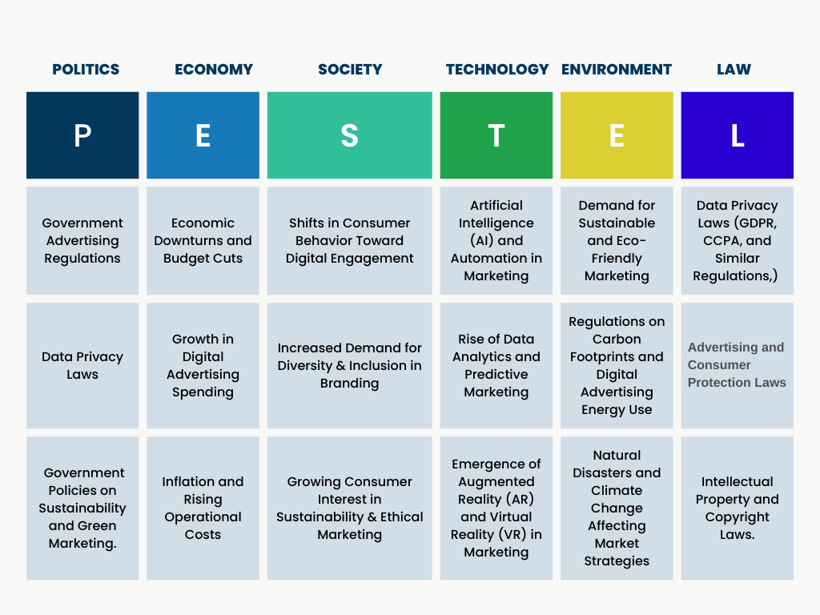
- SWOT Analysis
a. Strengths:
-Consistency of brand colors and logo usage
-Having a clear target audience
-Having lots of clients to work with
-Location: being in Southlake, Texas: Near Dallas, Fort Worth, Denton
-Well-defined offered services on the website
-Good use of 3-5 hashtags on each of the social posts
b. Weaknesses:
-Consistency of mission statement across social media
-Consistency of brand name across social media
-Having a large social media presence: room to grow
-No blog to improve on page SEO
-Limited on social pages to follow to Facebook, Instagram, and LinkedIn
c. Opportunities:
-Opportunity to create a newsletter
-Chatbot addition would help to improve engagement
-More Ai integration into social media and website
-Potential to explore paid media
-Might want to expand the target audience
d. Threats:
-Competing against larger competitors for clients
-TikTok may or may not disappear; taking away an opportunity to market
-Budget cuts from inflation may make it tougher to get tasks done easier
-Competitors offering both organic and paid media for brands
-Cross-platform integrations across social media: may want to see how to get Facebook up in views
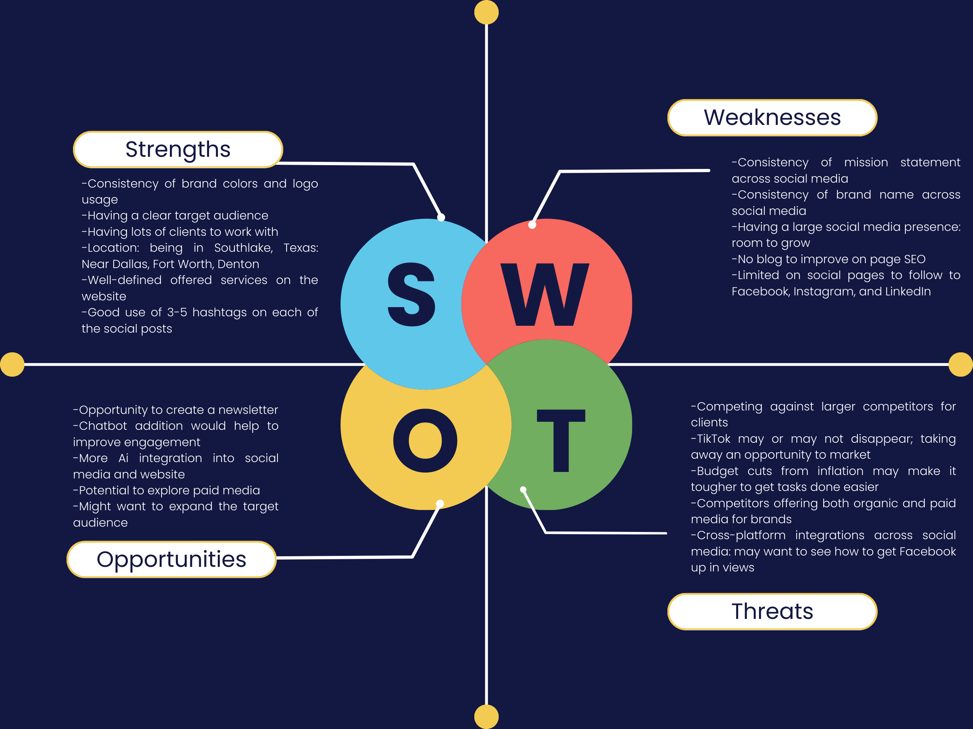

Citations:

Kelston | Marketing and Branding Studio in Southlake, TX. (n.d.). Kelston | Marketing and Branding Studio in Southlake, TX. https://tulip-chartreuse-5969.squarespace.com/
Lucky Shamrock (similar) Color | 4a787d. (n.d.). https://icolorpalette.com/color/4a787d
Stephanie Cross (n.d.). [LinkedIn page]. LinkedIn. Retrieved from https://www.linkedin.com/in/stephanierotherycross/

Kramer, J. (2024, May 8). How to Write a Mission Statement in 5 Steps - with Examples. Wix Blog. https://www.wix.com/blog/howtowriteamissionstatementgbraid=0AAAAADwEfwUdbVSgi_G6a2P0Tw2q4e94R&utm_source=google&utm_medium=cpc&utm_campaign=21334177617^168715657411^search%20%20dsa&experiment_id=^^726701436410^&gad_source=1&gclid=CjwKCAiA74G9BhAEEiwA8kNfp

How to write an Inspiring Content Marketing Mission Statement [Examples]. (2022, January 20). Content Marketing Institute. https://contentmarketinginstitute.com/articles/create-content-mission-statement/?utm_source=chatgpt.com

About Kelston Marketing | Dallas Marketing and Branding Studio — Kelston | Marketing and Branding Studio in Southlake, TX. (n.d.-b). Kelston | Marketing and Branding Studio in Southlake, TX. https://www.kelstonmarketing.com/about

Phelan, D. (2025, February 9). When will TikTok be back on iPhone now it’s returned for Android phones? Forbes. https://www.forbes.com/sites/davidphelan/2025/02/09/when-will-tiktok-be-back-on-iphone-now-its-returned-for-android-phones/

Larrison, B. (2025, February 4). Digital Advertising Regulation in 2025: What Marketers need to know. Basis Technologies. https://basis.com/blog/digital-advertising-regulation-what-marketers-need-to-know

OpenAI. (2025). ChatGPT (Feb 2025 version) [Large language model].

Bowler, H. (2025, January 6). How should CMOs prepare for ‘anemic budget growth’ in 2025? The Drum. https://www.thedrum.com/news/2024/12/17/how-should-cmos-prepare-anemic-budget-growth-2025

Collective Alternative. (n.d.). The importance of marketing as inflation settles - collective alternative. https://www.collectivealternative.com/the-importance-of-marketing-as-inflation-settles/

Dodds, D. (2024, August 13). Short-Form Video Content: Capturing attention in the Digital age. Forbes. https://www.forbes.com/councils/forbesagencycouncil/2024/03/19/short-form-video-content-capturing-attention-in-the-digital-age/

McCormick, K., & McCormick, K. (2025, January 7). 76 Perspective-Broadening Stats about Diversity & Inclusion in Marketing for 2025. WordStream. https://www.wordstream.com/blog/ws/2023/02/27/diversity-inclusion-marketing-statistics#:~:text=Some%2059%25%20of%20consumers%20polled,in%20online%20advertising%20(Facebook).

